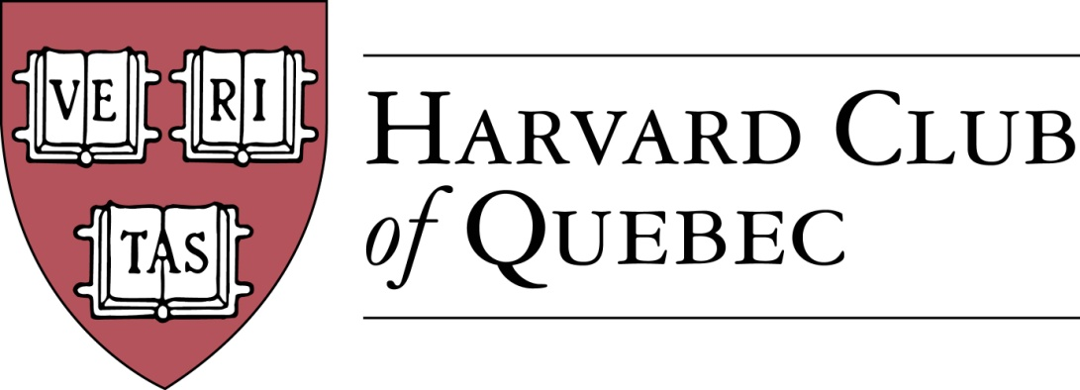
Minutes of the Harvard Club of Québec Board of Directors Meeting
Held on 22 November 2016 in Montréal

PRESENT: Marc Novakoff (President), Han-ru Zhou (Executive Vice-President), Anna Piotrowska (Secretary), Marco Cianflone (Treasurer), Joseph Cianflone (Director PR via telephone), Alexandre Abecassis (director at large), André Picard (director at large), Morgan Carter (Director at large).
OBSERVERS : Solange Blanchard, Matt Desruisseau
ABSENT: Marie-Pier St-Hilaire, Erinn Wattie, and Louis Philippe Maurice

- QUORUM
Anna Piotrowska confirms that there is quorum and that the meeting can proceed.

- MINUTES OF THE PAST MEETING
The minutes of the September 20th meeting are approved.

- REVIEW OF PAST ACTIVITIES
  - 26 September – US Elections/MTL Press Club (JC)/University Club
  - 6 October - 5th joint HCQ-Cirano Event (MN) with Harvard Professor Kane & Professor Castonguay
    - Discussion about how financial aspects of the series are handled by the HCQ and CIRANO.
  - 23 October – Apple Picking Family Event (AKP)
  - 3 November - Lord Reading Society and the Canadian and Israeli Commissioners of Patent (AA & HRZ)
    - Alexandre Abecassis will confirm how many participants came from the Harvard network
  - 19 November - Harvard-Yale game (MC)
    - This family-friendly venue can be used for future events of this type. Around 22 participants.

- FINANCE/TREASURY
  - Treasury Review (MC)
    - HRZ suggests that banking fees should be waived due to the non-profit status of the Club.
  - Club Status Committee Update (HRZ)
    - HRZ remarks that any corporate changes must be now filed with the register des entreprises.
  - Sponsorship Committee and Program (JC + SB)
    - Template letter & “Package” will be ready for the mid-February event. The designs will be presented at the next board meeting.

- BUILDING UP THE CLUB
  - Active members: 234 => 236 (AKP)
  - Friends of Club list: 191 (JC)
    - AKP and JC will meet to solve some issues about membership lists and communication methods.
  - Facebook Page Members: 135 => 137 (CW)

- Communication/Advertising/Sponsorship (JC/CW/SB)
  - Digital Strategy (JC & CW)
  - Website (JC)
    - AKP, JC, and HRZ will try to solve these issues at their next meeting.
  - Tools
    - Events Portable Banner (JC & MC)
      - These are being prepared and should be ready in February.
  - Events advertising/publicity (JC)
    - Media coverage

- Multi-Club Efforts (JC)
  - Regular luncheons update
    - A luncheon will be scheduled in mid-January.
  - Events
    - There has been no progress on the Hungary Club – Justin Trudeau event, so it is dropped from the agenda.
    - Garden Party will be considered in the summer.
  - Book Club (SB)

- 2017 FORTHCOMING EVENTS
  - Le Chainon charity event date is proposed for 3rd week of January
  - Anna will take the lead on the Cleaning of Mont Royal charity event in May
  - 11 January – GNN (MC)
  - The Social Entrepreneurship Event will take place at the end of February and will include a cocktail reception, a panel and breakout sessions. Solange will collaborate with Morgan Carter on this event.
  - Regarding the Speaker Series For Young Professionals (SSFYP)--Mitch Joel from Twist Image, Andre Picard will follow up with the author and confirm his availability and honorarium in January. If no confirmation, the event will be dropped from the agenda.
  - Museum of Fine Arts Event with Hilliard Goldfarb (JC + Arts Committee)—March or April
  - History of the Russian Consulate in Montreal Event (MN) => Marc will fix the date after having lunch with the consul.
  - MAC (Musee d’Art Contemporain), Alexandre Taillefer (AP) => Spring
  - Global Diplomacy Lab (MC, JC, LP) is dropped from the agenda due to lack of progress.
  - New City Vanguard Conference (MC)
  - The Annual Quebec City Club Dinner (MPS/BP?) might also need to be killed due to lack of interest and progress.

- Harvard High-School Book Awards (MN)—the name is changed to Harvard Excellence Book Award
  - College Jean-De-Brebeuf - HRZ
  - Marianopolis College – MM/AP—Andre Picard suggests to buy hard cover books, a piece of merchandise, organize info sessions and mentoring activities to accompany the prize. The Club’s mission should be to encourage students to apply for Harvard, among other things.
  - Royal West High School – MMC
  - College Stanislas – MN
  - Marco might sponsor on at St. Thomas

- Nominating committee: MN, AKP, HRZ
  - New potential Officers
  - New potential Directors

- Next Board Meetings & AGM date
  - January 11, 2017
  - March 15, 2017

- Others/Varia
  - 2017 - Montreal 375 Anniversary
  - Scholarship to honour Governor General David Johnson—$100,000 sought, contributions welcome.
  - It is decided that at the next meeting, the following items will be discussed: Speaker Series for Young Professionals (keep or kill), presentation of the promotional package, and the date of the MAC event.

The meeting was adjurned at 8 pm.

* * *

Minutes prepared by Anna K. Piotrowska.

Marc Novakoff  President | Anna K. Piotrowska  Secretary

MN/AKP

