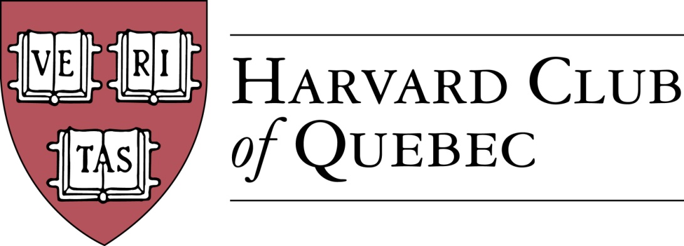

Minutes of the Harvard Club of Québec
Board of Directors Meeting

September 12, 2018, 18:00-19:30
Fasken Martineau DuMoulin, 800, rue du Square-Victoria, bureau 3700, Montréal, Québec

PRESENT: Han-ru Zhou (President), Marco Cianflone (Executive Vice-President), Anna Piotrowska (Secretary), Joseph Cianflone (VP External Relations), Alexandre Abecassis (Treasurer), Samuel Shapiro (Director of Communications); Derek McKee (director)
Officers: Ben Poirier and Mariama Keita

ABSENT: Matt Desruisseaux, Morgan Carter, Solange Blanchard

AGENDA

- QUORUM (AKP)-quorum confirmed

- ADOPTION OF THE AGENDA (AKP)-agenda adopted

- MINUTES OF PAST MEETING(S) (AKP)—minutes approved

- COMMUNICATIONS (SS)
  - Online Strategy
    - Website
    - Social media (SS/HRZ)
  - Newsletter—format and timing of the newsletter are discussed. Newsletter is essentially a compilation of upcoming event announcements.

- CORPORATE MATTERS (HRZ)
  - Directors & Officers Contact List—ACTION: Anna will confirm the contact information of absent directors as well as those calling in the absent directors
  - Directors & Officers Liability Insurance (D&O)— Motion to set up an ad hoc committee to investigate the following: 1) check with HAA and establish best practices among other clubs, 2) examine the level of liability and risk, 3) ask quotes from a few insurers and description of coverage. The Committee is composed of: Derek McKee (Chair), Marco Cianflone and Joe Cianflone ACTION: the committee will report on its findings and present its recommendations at the next board meeting in January 2019.

- SPONSORSHIPS (SB)—new sponsorship opportunities are discussed

- REVIEW OF PAST ACTIVITIES—events proposed by non-directors or non-officers should be approached with caution.
  - Mexican Ambassador to Canada Dionisio Pérez-Jacome & HKS Prof. Robert Lawrence on NAFTA (HRZ) => April 6, 2018
  - Cabane à sucre (HRZ) => April 22, 2018
  - 10 Theses on Canada in the world in the 21st Century with Dr. Irvin Studin (Diego Osorio) => May 2, 2018
  - Mont-Royal Clean-Up => May 5, 2018
  - AGM (MC) => June 18, 2018

- FINANCE/TREASURY (AA)—interim financial statements are discussed

- BUILDING UP THE CLUB (AKP)—ACTION: Anna will reconcile the new HAA alumni list with the current list of active members and present the results at the next board meeting
  - Active members: 286 => 287
  - Friends of Club: 128 => 169 – it should be kept in mind that the list of friends fluctuates over the year, as members change jobs and can no longer be reached through the email addresses they originally provided. ACTION: the Secretary will periodically enter HCQ gmail account and screen for undeliverable messages and remove related names and addresses from the friends list.
  - Facebook Page Members: 180 => 190
  - LinkedIn Group Members: 51

- FORTHCOMING EVENTS
- Club Annual Dinner in Quebec City with US Consul General (BP/HRZ) => September 28, 2018
  - Final decision will be made after September 19th, the rsvp deadline
- Apple-Picking (AKP) => October 14, 2018 (alternative date: October 21)
- Welcome to Your City (MC) => October 18, 2018
- Orchestre Métropolitain & Maestro Yannick Nézet-Séguin (MD) => October 28, 2018
- Harvard-Yale Game (MC) => November 17, 2018
- Global Networking Night (MC) => January 9, 2019
- Marc-André Blanchard, Canadian Ambassador to the UN (HRZ) => winter 2019
- Museum of Fine Arts Calder Exhibit with Anne Grace & Hilliard Goldfarb (MD) => Winter 2019

- POTENTIAL EVENTS
  - Habs vs Canes (MC) => November 27, 2018
  - Mélanie Joly (HRZ) => winter 2019
  - Grands Ballets (MD) => spring 2019
  - Annual Cocktail Reception at the US Consul Residence (JC) => 2019
  - MAC (Musee d’Art Contemporain) & Alexandre Taillefer (MD)
  - Italian Consul (MC)
  - SAP sponsored events (SB)
  - Garden Party with Oxbridge (JC)
  - M. Côté, PDG Investissement Québec (SB)

- COMMUNITY SERVICE INITIATIVES (AKP/MMC)
  - Mont-Royal Clean-Up or Le Chainon volunteering => May 2019

- EXTERNAL RELATIONS (JC)
  - McGill Meets Ivy League - Networking cocktail => April 17, 2018
  - Multi-Club initiatives

- HARVARD PRIZE BOOK PROGRAM
  - Marianopolis College – Mitch Miller
  - Royal West High School – MMC
  - Selwyn House – Noah Bloom ‘01 (looking for successor for next year)
  - St-Thomas – MC
  - College Stanislas – MN/AKP
  - Marie-de-France – MN

- NOMINATING COMMITTEE (HRZ/MC/AKP)
  - New potential Officers
  - New potential Directors

- NEW POTENTIAL COMMITTEES
  - Young Alumni Committee
  - Prospective Students Committee (MK) – this initiative is shelved

- NEXT BOARD MEETING
  - January 16, 2019

- OTHERS/VARIA

Board meeting is adjourned at 7.36 pm

HRZ/AKP

