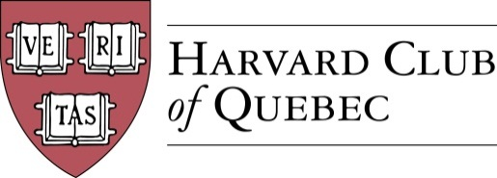

MINUTES OF THE HARVARD CLUB OF QUÉBEC ANNUAL GENERAL MEETING

Held on Monday, June 22, 2015, 5pm
at Rosalie, 1232 Rue de la Montagne, Montréal, QC, H3G 1Z1

1. Quorum

H-R Zhou, Secretary of the Club, confirmed that there is quorum and that the meeting can proceed.

2. Approval of the Minutes of the HCQ Annual General Meeting held on 3 June 2014

The minutes of the Club’s Annual General Meeting held on 3 June 2014 are approved.

3. Report of the President

A Du Sault, President of the Club, reviewed the Club events held during the past year.

A Du Sault presented an overview of the Club events planned for the coming year.

4. Approval of the Club Constitution

H-R Zhou presented the main modifications to the Club Constitution. The draft Constitution was approved by the HAA on 10 June 2015 and by the Board of Directors of the Club at its meeting on 16 June 2015. The draft Constitution was circulated to the Members of the Club along with the notice of the Annual General Meeting.

The Members of the Club unanimously approved the Club Constitution. The Club Constitution is adopted.

5. Annual Financial Statements

The Members of the Club were presented with the Club’s Annual Financial Statements for the period from 3 June 2014 to 22 June 2015. As of 22 June 2015, the balance in the Club bank account stands at $3,261.36.

The Club’s Annual Financial Statements for the period from 3 June 2014 to 22 June 2015 are approved.

6. Election of Directors and Officers for 2015-2016

The Board expressed its thanks to A Du Sault, L Alcoloumbre and E Wattie for their service on the Club’s Board of Directors.

The new candidates standing for election to the Board of Directors of the Club briefly introduced themselves.

DIRECTORS AND OFFICERS 2015-16
President: Marc Novakoff, MBA 2003
Executive Vice President: André Picard, AB 1987, AMP 2000
Secretary: Han-Ru Zhou, LLM 2005
Treasurer: Marco Cianflone, AB 2013
Vice President Communications: Mitchell Miller, EdM 2011

OTHER DIRECTORS 2015-16
Director Communications: Cassie Wang, AB 2012
Director (Québec City): Marie Pier St-Hilaire, OPM 2012
Director: Morgan Carter, MAR 2010
Director: Louis Philippe Maurice, MBA 2008
Director: Joseph Cianflone, AB 2007
Director: Alexandre Abecassis, PLDA14(18)

All the candidates were elected at their respective post and office for the year 2015-16, except M Novakoff who was elected President of the Club for a term of two years pursuant to the Club Constitution.

7. Proposed Board of Governors

In accordance with the Club Constitution, A Du Sault and M Novakoff agree to set up the Club’s new Board of Governors.

8. General Business

There was no general business.

The meeting concluded at 5:41pm.

* * *

Minutes prepared by Han-Ru Zhou, HCQ Secretary.

André Du Sault  President | Han-Ru Zhou  Secretary

