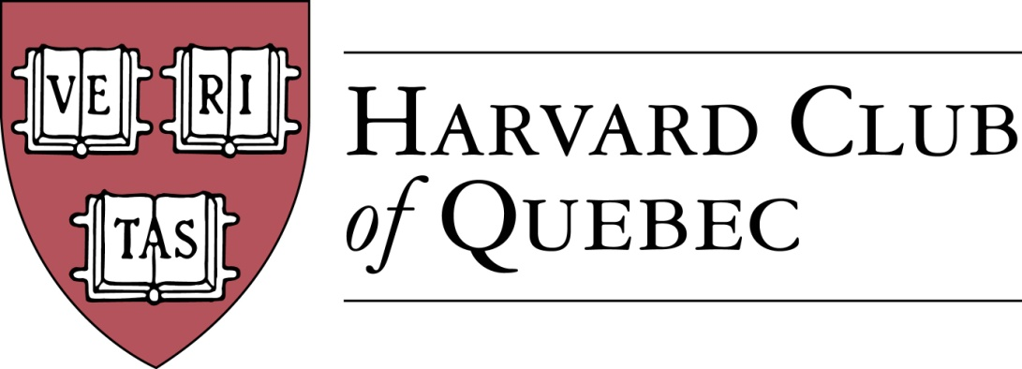
Minutes of the Harvard Club of Québec Board of Directors Meeting
Held on 20 September 2016 in Montréal

PRESENT: Marc Novakoff (President), Han-ru Zhou (Executive Vice-President), Anna Piotrowska (Secretary), Marco Cianflone (Treasurer), Joseph Cianflone (Director PR), Cassy Wang (VP Communications), Morgan Carter (Director at large).
OBSERVERS : Solange Blanchard
ABSENT: André Picard, Alexandre Abecassis, Marie-Pier St-Hilaire, Erinn Wattie, and Louis Philippe Maurice

- Quorum
Anna Piotrowska confirms that there is quorum and that the meeting can proceed.

- Approval of Minutes from March 24th 2016
The Board approved the amended minutes of its meeting held on 24 March 2016.

- Nomination of new officers
The nominating committee (MN, AP, HRZ) nominated Solange Blanchard and Matthieu Des Ruisseaux as events officers.

- Review of past HCQ activities
Board members reported on the following HCQ activities held since the last board meeting: Cabane a Sucre (2 April 2016); US Consult reception (8 June - US Consul Event); Annual General Meeting at Rosalie and Global Networking Night (June 15, 216)

- Finance, Treasury, and Club Status Report
Tresurer Marco Cianflone presented the Club’s Interim Financial Statements for the period from June 15th 2016 to September 20th 2016. As of September 20th, 2016, the balance in the Club bank account stands at $3,062.08.
Han-ru Zhou reported on the successful registration of the HCQ as a “non-profit legal person.”

- Club membership and communication
AKP presented the updated list of the Club members. As of September 20th, 2016, The Club has 236 members.
The current Friends of the Club list (non-alumni) comprises 30 names. The Board discussed the necessity of synchronizing this list with that of google mailing list of friends of the club, which comprises around 200 persons (JC).
It was decided that for event communication purposes, the Club will use the HAA Magnet distribution list (accessible via the HCQ website) which consists of Quebec-based alumni who opted for alumni communications. The Friends of the Club will be notified via the google maling list.
Cassy Wang presented the Facebook page membership which has grown from 121 to 135 members. She also called for submissions to the 3rd edition of the HCQ newsletter to be published in January 2017.
Joseph Cianflone reported on his regular communications with the other alumni clubs and prospective joint events.
The Board discussed advertising and sponsorship opportunities offered by events and newsletters, as well as tools that are currently being developped to support these initiatives.

- Community Service
The Global Month of Service being now defunct, there is more flexibility in scheduling community service events throughout the year. MMC proposed volunteering at La Chainon (possibly in December 2016, MMC) and AKP proposed cleaning of the Mt Royal Parc (an annual initiative of Les amis de la Montagne) in May 2017.

- Events forthcoming in 2016
The Board reviewed and discussed the following Club events: 26 September – US Elections/MTL Press Club (JC); 6 October - 5th joint HCQ-Cirano Event (MN); 23 October – Apple Picking Family Event (AKP); 3 November - Lord Reading Society and the Canadian and Israeli Commissioners of Patent (AA & HRZ); 19 November - Harvard-Yale game (to be taken over by Marco Cianflone). The Board discussed sponsorship opportunities offered by some of these events.

Given logistical and scheduling constraints, the Board decided to postpone the following events to 2017: Social Entrepreneurship Event (LP) and Speaker Series For Young Professionals (SSFYP) featuring Mitch Joel from Twist Image Author of Six Pixels of Separation and Ctrl, Alt, Del (this event will be coordinated by Solange Blanchard in collaboration with Andre Picard)

- 2017 Forthcoming Events
The Board discuss the scheduling and feasibility of the following events:
- Museum of Fine Arts Event with Hilliard Goldfarb (JC + Arts Committee)
- History of the Russian Consulate in Montreal Event (MN) => Spring
- MAC (Musee d’Art Contemporain), Alexandre Taillefer (Solange Blanchard in collaboration with AP) => Spring
- Global Diplomacy Lab (MC, JC, LP)
- New City Vanguard Conference (MC)—might not be feasible due to short timeline.
- Annual Quebec City Club Dinner (MPS) => Date?
  - La Citadelle de Québec - Le Cercle de la Garnison
  - Invitation to US Consul

- Harvard High-School Book Awards (MN)
The Board discussed the award schemes current in place at College Stanislas (MN), College Jean-De-Brebeuf (HRZ), Marianopolis College (MM/AP), and Royal West High School (MMC).

The meeting was adjurned at 19.30.

* * *

Minutes prepared by Anna K. Piotrowska.

Marc Novakoff  President | Anna K. Piotrowska  Secretary
MN/AKP

