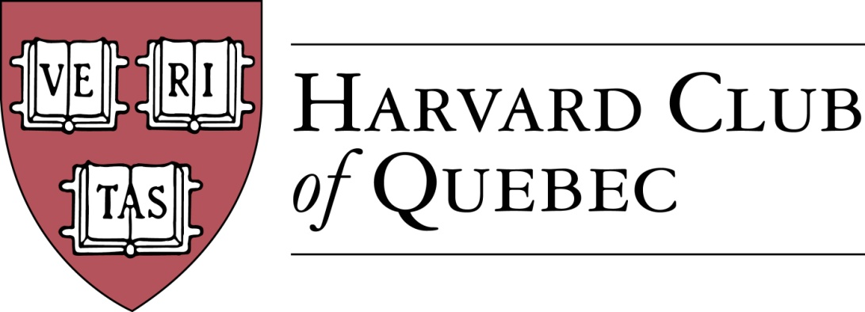 Montreal, March 21, 2017

Minutes of the Harvard Club of Québec
Board of Directors Meeting
Held on 21 March 2017 in Montréal

PRESENT: Marc Novakoff (President), Han-ru Zhou (Executive Vice-President), Anna Piotrowska (Secretary), Marco Cianflone (Treasurer), Joseph Cianflone (Director PR), Alexandre Abecassis (director at large), Erinn Wattie (director at large)
OBSERVERS : Solange Blanchard, Matt Desruisseau
ABSENT: Marie-Pier St-Hilaire, Louis Philippe Maurice, Morgan Carter, André Picard, Cassy Wang

AGENDA:

- QUORUM (AKP)-Quorum is confirmed
.
- MINUTES PAST MEETINGS (AKP)-Approved

- REVIEW OF PAST ACTIVITIES- in the future, it will be specified if the events are held in English or French
  - 13 March – France Ambassador to Canada (Telus Sponsored)
  - Added item: Harvard Alumni Leadership Conference in February

- FINANCE/TREASURY-
  - Treasury Review (MC) –the current balance doesn’t include the profit from the French ambassador event
  - Club Status Committee Update (HRZ)—the June AGM of the Club will be the first one since the incorporation. HRZ will take action in preparation for this meeting.

- BUILDING UP THE CLUB
  - Active members: 241 => 246 (AKP) – HRZ will reconcile this number with 2016 number of 257.
  - Friends of Club list: 128 (HRZ) – HRZ crosschecked the lists and reconciled them.
  - Facebook Page Members: 140 => 141 (CW)

- PROCEDURE FOR ADDING NEW MEMBERS AND FRIENDS + CONSOLIDATED CONTACT LISTS (HRZ) – HRZ describes the new procedure. It is suggested to download the Magnet alumni contacts before every meeting and check the opt-in option.

- 2017 FORTHCOMING EVENTS
  - 3 April – Guy St-Jacques, Former Canadian Ambassador to China
    - Lunch presentation on China and Geopolitics – Solange took the lead on sponsorship and it will be the first use of HCQ sponsorship package.
  - 8 April – Le Chainon 9:30am-3:30pm (AKP) – more participants needed
  - XX April – Sugar Shack (MC) – Target date: Sunday, April 23; Marco will make appropriate arrangements
  - XX May - Social Entrepreneurship Event (MMC/LP)
    - Sid Lee Location, 4-6 persons panel, multi-club event, HAA Speaker Bureau—Marc will follow up
  - May-June-Cleaning Mt Royal (AKP)—it will be done in May
  - Speaker Series For Young Professionals (SSFYP) with Mitch Joel from Twist Image (AP)—Marc will follow up
  - Museum of Fine Arts Event with Hilliard Goldfarb (JC + Arts Committee) – 1) guided tour of the Chagall exhibit followed by drinks at a nearby bar. Target date: May. 2) Potential event of Grands Ballets. Target date: Fall. 3) Potential event with the director of the Orchestre Metropolitain (HRZ).
  - US Consul Residence Event –Joe will follow up.
  - History of the Russian Consulate in Montreal Event (MN) => Spring – no updates
  - MAC (Musee d’Art Contemporain), Alexandre Taillefer (AP) => Spring – no updates.
  - New City Vanguard Conference (MC) – no updates
  - Quebec City Events (HRZ) – HRZ will get in touch with Ben Poirier to organize the annual dinner for the fall.
    - La Citadelle de Québec - Le Cercle de la Garnison
    - Invitation to US Consul
Suggestions for new events: apple picking (AKP); Italian consul around the free trade agreement; sponsored series of speakers
Added item: College admissions and meeting with Prof. Paul Lasko, regional chairperson for Quebec. Anna will meet with Paul Lasko next week.

- Communication/Advertising (HRZ/AKP/CW)
  - Digital Strategy (HRZ & AKP)
    - Website
  - Newsletter (CW)
    - 3rd Edition input
  - Communication Templates (SB)—logo, Harvard Club presenting, theme, narrative, sponsor information, standard disclosure

- Sponsorship (SB)-the sponsorship package will be finished within a week. The banner is presented at the meeting. All sponsor matters should be directed to Solange. Nobody can sign an agreement without a review by HRZ and SB. The President will sign all agreements. Bringing in a sponsor might require a Board vote. It was noted that the mission of the Club will not be negatively affected by the sponsorship efforts.
  - Tools
    - Template letter & “Package” (SB)
    - Events Portable Banner (JC & MC)

- External Relations (JC)
  - Multi Club events
    - Regular luncheons update
    - Events--Garden Party in the summer
    - Book Club (SB)
  - Public relations (JC)
    - Media coverage
  - Community service engagements—concerns about low participation of the Chainon event

- Harvard Prize Book Program (MN)
  - College Jean-De-Brebeuf - HRZ
  - Marianopolis College – MM/AP
  - Royal West High School – MMC
  - St-Thomas - MC
  - College Stanislas – MN
  - Others

- Nominating committee: MN, AKP, HRZ
  - Retiring directors: Erinn Wattie, Cassy Wang, Marie-Pierre, LP Maurice
  - New potential Officers
  - New potential Directors (SB & MD) – Solange, Matt, Derek, Ben Poirier

- Next Board Meetings & AGM date
  - GNN New Location (MC)-no Board meetings between now and the GNN

- Others/Varia
  - 2017
    - Montreal - 375 Anniversary
    - Canada – 150 Anniversary
    - Expo 67 – 50 Anniversary

Meeting adjourned at 8 pm.

Minutes prepared by Anna Piotrowska.

Marc Novakoff  President | Anna Piotrowska  Secretary

MN/HRZ/AKP

