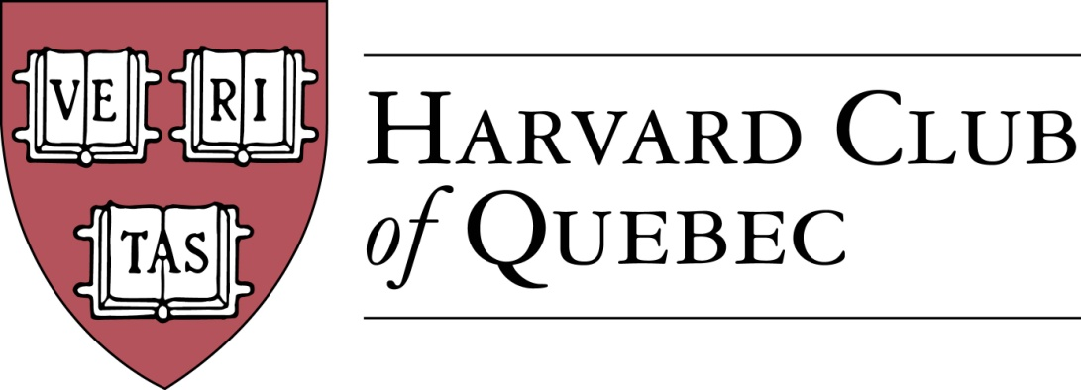

Minutes of the Harvard Club of Québec
Board of Directors Meeting
Held on January 9, 2018, 17:00-18:00, in Montréal

PRESENT: Marc Novakoff (President), Han-ru Zhou (Executive Vice-President), Anna Piotrowska (Secretary), Marco Cianflone (VP Communications), Matt Desruisseau, Alexandre Abecassis (Treasurer), Solange Blanchard, Derek McKee
ABSENT: Joseph Cianflone, Morgan Carter, André Picard

AGENDA:

- QUORUM (AKP) --confirmed

- ADOPTION OF THE AGENDA (AKP) -- adopted

- MINUTES PAST MEETINGS (AKP) --adopted

- REVIEW OF PAST ACTIVITIES
  - 19 October – Welcome to Your City Fall 2017 (MC) – 6-7 people attended, mostly young alumni.
  - 18 November – Harvard-Yale Game at Atwater Club (MC)

- FINANCE/TREASURY (AA)

Related action items :
- Produce an updated statement with right timing.
- Reset the online access by the March 22 meeting.
- Job description for the treasurer : Marco will draft it and Alexandre will review it. One of the responsibilities will be taking pictures of all receipts and filing them on the Gdrive (Anna has already created a folder)
- Consider auditing of statement to be considered, especially as the funds go up.

- BUILDING UP THE CLUB
  - Active members: 286 => 286
  - Friends of Club: 125 => 127
  - Facebook Page Members: 169 => 176

Action items :
- Marco will forward the participants of the past two events to Anna so that she can check the lists for any new members.

- FORTHCOMING EVENTS
January 2018 | Jan. 9: GNN | Marco C.
February 2018 | TBC: Meeting with the Italian Consul | JC/Marco
March 2018 | TBD: History of the Russian Consulate in Montréal | MN
April 2018 | April 6: Mexican Ambassador to Canada & HKS Prof. Robert Lawrence on NAFTA (April 6, 2018)  TBC: Cabane a sucre (2 weeks later)  TBC: Grand Ballets | HRZ  AKP  MD
May 2018 | TBD: Cleaning of Mt Royal (Community Service)  TBD : M. Côté, PDG Investissement Québec, Telus Hosted  TBD: Reception at American Consul’s Residence | AKP  SB  JC
June 2018 | TBC: GNN and AGM | Marco C

- POTENTIAL EVENTS
  - Montreal Canadians’ Behind the Scenes Tours (Marc)
  - Meeting with the Italian Consul (JC/Marco)
  - André Haddad’s talk on reputation
  - Social Entrepreneurship Event (MMC/LP)--Sid Lee Location, 4-6 persons panel, multi-club event, HAA Speaker Bureau
  - Speaker Series For Young Professionals (SSFYP)--Mitch Joel from Twist Image (AP), Author of Six Pixels of Separation and Ctrl, Alt, Del.
  - Museum of Fine Arts Event with Hilliard Goldfarb (JC + Arts Committee)
  - SAP sponsored events (SB)—need to be restarted after personnel change
  - Associate Justice Stephen Breyer (SCOTUS) (HRZ)
  - Garden Party with Oxbridge and other multi-club initiatives (JC)
  - TBC: MAC with Alexandre Taillefer (AP)

- COMMUNITY SERVICE INITIATIVES (MMC/AKP)
  - See the cleaning of Mt Royal above

- COMMUNICATIONS/ADVERTISING (MC)
  - Digital Strategy (MC)
    - Website
    - Social media
  - Newsletter (MC)
    - 3rd Edition input
    - Advertising
  - Communication and Event Templates

- SPONSORSHIPS (SB)
  - Template letter & “Package” (SB)
  - Events Portable Banner (JC/MC)
  - 2018-19 Preliminary Calendar of Club Events (HRZ/AKP/SB)

- EXTERNAL RELATIONS (JC)
  - Events advertising/publicity & media coverage
  - Multi-Club initiatives

- HARVARD PRIZE BOOK PROGRAM
  - Marianopolis College – MM/AP
  - Royal West High School – MMC
  - St-Thomas – MC
  - College Stanislas – MN/AKP
  - Marie-de-France – MN
  - Collège de Montréal – Martine Valois, LL.M. ’91
  - Other – HRZ

Action item :
- Book prize tab will be added to the website.

- NOMINATING COMMITTEE (MN/HRZ/AKP)
  - New potential Officers
  - New potential Directors

- NEW POTENTIAL COMMITTEES
  - Young Alumni Committee (JC)
  - Prospective Students Committee with Claude Roy as potential Officer (MN)

- NEXT BOARD MEETINGS & AGM (MN)
  - Next BoD meeting: Thomson House, McGill, Room 406, March 22, 5pm to 7pm
  - AGM/GNN/New board meeting (MN/MC) - TBC

- OTHERS/VARIA

There being no further business, the meeting concluded.

* * *

Minutes prepared by Anna K. Piotrowska.

Marc Novakoff  President | Anna K. Piotrowska  Secretary

MN/HRZ/AKP

