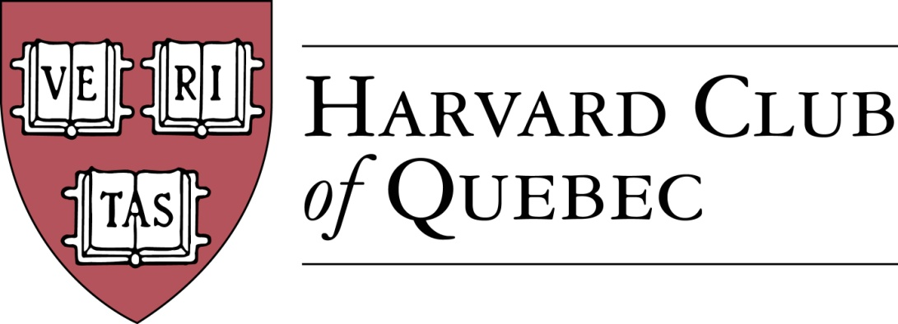

**ANNUAL GENERAL MEETING**

**Thursday, June 29, 2023 – 5:15 p.m.**

Chez Alexandre, Montreal

**AGENDA**

1. QUORUM
2. ADOPTION OF THE AGENDA
3. MINUTES OF THE LAST ANNUAL GENERAL MEETING HELD ON JUNE 14, 2022
4. PRESIDENT’S REPORT
5. EXAMINATION AND APPROVAL OF THE ANNUAL FINANCIAL STATEMENTS
6. ELECTION OF DIRECTORS AND OFFICERS

|  |  |  |
| --- | --- | --- |
| **Title** | **Holder** | **Harvard Affiliation** |
| President | Marco Cianflone | Harvard College  AB 2013 |
| Executive Vice-President  Treasurer | Joseph Cianflone | Harvard College  AB 2007 |
| Secretary | Samuel Shapiro | Harvard College  AB 2008 |
| Director, Communications | Kendra Gray | Harvard Extension School  ALM 2011 |
| Director, Community Outreach | Michael Looft | Harvard Divinity School  MDV 2009 |
| Director, Arts | Hilliard Goldfarb | Graduate School of Arts and Sciences  AM 1974  PhD 1980 |
| Director at Large | Suzanne Bays | Fellow, Advanced Leadership Initiative  UFI 2019 |
| Director at Large | Sami Boutaleb | Harvard Business School  PLDA 2014(19) |
| Officer | Ben Poirier | Harvard Business School  PMD 2004 |

1. GENERAL BUSINESS – DIRECTOR & OFFICER ROUNDTABLE
2. OTHER BUSINESS – TOWN HALL
3. DATE AND TIME OF NEXT BOARD MEETING
4. ADJOURNMENT OF THE MEETING

MC/SS