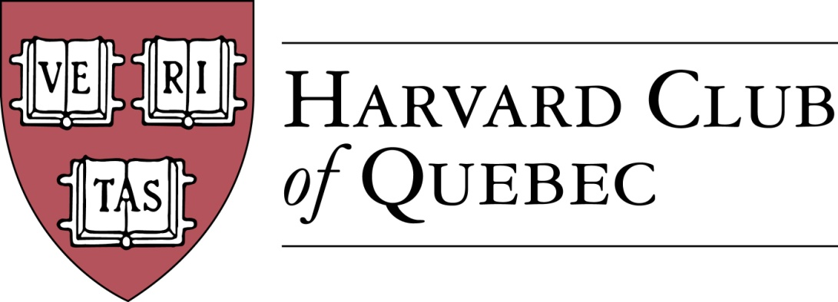

Minutes of the Harvard Club of Québec
Board of Directors Meeting

January 16, 2019, 18:00-19:30
Sectoral Asset Management, 1010 Sherbrooke St. West #1610, Montreal, QC, Canada H3A 2R7 (entrance on Metcalfe Street)

Contact: Marco Cianflone (514-940-8082)

PRESENT: Han-ru Zhou (President), Marco Cianflone (Executive Vice-President), Anna Piotrowska (Secretary), Joseph Cianflone (VP External Relations), Alexandre Abecassis (Treasurer), Samuel Shapiro (Director of Communications); Solange Blanchard (Director of Sponsorships); Derek McKee (director)

Officers: Ben Poirier

ABSENT: Matt Desruisseaux, Morgan Carter

AGENDA

- QUORUM (AKP)—quorum is confirmed

- ADOPTION OF THE AGENDA (AKP)—agenda is adopted

- MINUTES OF PAST MEETING (AKP)—minutes are approved

- COMMUNICATIONS (SS)
  - Online Strategy and Website
    - Com Director is monitoring the # of unsubscribe request per post (1-2 only)
    - ACTION ITEM: Harvard Book Prize page needs to be added to the website (Samuel).
    - Event posting strategy—Friday evening and Monday morning are the optimal times; weekends should be avoided
  - Updated Communications Checklist—event organizers are reminded to post blurbs with photos on Facebook Group and email photos to the President for cross-posting on LinkedIn Company page and Twitter
  - Newsletters—Magnet-generated templates should be used for all email event announcements and upcoming events newsletters.

- BUILDING UP THE CLUB (AKP, HRZ)
  - Active members: 287 => 209
  - Friends of Club: 169 => 140
  - Facebook Page Members: 190 => 199
  - LinkedIn Group Members: 51 => 58
  - LinkedIn Company Page Followers: 14
  - Twitter Followers: 10

- CORPORATE MATTERS
  - Directors & Officers Liability Insurance (DM)—after some preliminary investigation Derek is filling out forms to get proper estimates; insurance history of individual directors and members is relevant. ACTION ITEMS: Joe will contact HAA about best practices and the Harvard Club of Toronto for their strategy; Derek will contact directors with requests for information in order to finalize quotes.

- SPONSORSHIPS (SB)—prospective sponsors would like to know in advance the calendar of events for the entire year, but Solange and other Board members acknowledged that the Club currently doesn't have the resources to plan all its events a year ahead and some speakers would not commit to an event with us so long in advance.

- FINANCE/TREASURY (AA)
  - ACTION ITEM: post 2018 financial statements online (Alexandre and Samuel)

- REVIEW OF PAST ACTIVITIES
- Apple-Picking (AKP) => October 14, 2018
- Welcome to Your City (MC) => October 18, 2018
- Orchestre Métropolitain & Maestro Yannick Nézet-Séguin (MD) => October 28, 2018
- Harvard-Yale Game (MC) => November 17, 2018
- Global Networking Night (MC) => January 9, 2019

- FORTHCOMING EVENTS
- Museum of Fine Arts Calder Exhibit with Anne Grace & Hilliard Goldfarb (MD) => Winter 2019—SOLD OUT
- HAA Alumni Leadership Conference, Cambridge MA (HRZ) => February 6-8, 2019
- HLS Prof. Michael Klarman on the Trump Administration (HRZ) => March 28, 2019
  - ACTION ITEMS: Opening this event to new admits and notifying HAA to advertise it to them (Han-ru Zhou)
- Sugar Shack at Sucrerie La Montagne (HRZ) => April 27, 2019
- Orchestre Métropolitain (HRZ/MD) => fall 2019

- POTENTIAL EVENTS
  - Habs vs Canes (MC) => winter 2019
  - Marc-André Blanchard, Canadian Ambassador to the UN (HRZ) => winter/spring 2019
  - Mélanie Joly (HRZ) => winter/spring 2019
  - Grands Ballets (MD) => spring 2019
  - Annual Cocktail Reception at the US Consul Residence (JC) => spring 2019
  - MAC (Musee d’Art Contemporain) & Alexandre Taillefer (MD)
  - SAP sponsored events (SB)
    - ACTION ITEM: connect Solange with the event person at SAP for a follow-up (Anna)
  - Garden Party with Oxbridge (JC)
  - M. Côté, PDG Investissement Québec (SB)
ACTION ITEM : Samuel and Marco will inquire about potential events (Summer Rogers Cup and Just for laugh, respectedly).
Events f, h, and i will be removed from the list, as no progress has been made on them.

- COMMUNITY SERVICE INITIATIVES (AKP/MMC)
  - TBD => May 2019
ACTION ITEM: Anna will investigate new opportunities for community engagement.

- EXTERNAL RELATIONS (JC)
  - Multi-Club initiatives

- HARVARD PRIZE BOOK PROGRAM
  - Marianopolis College – Mitch Miller
  - Royal West High School – MMC
  - Selwyn House – MMC?
  - St-Thomas – MC
  - College Stanislas – MN/AKP
  - Marie-de-France – MN

- NOMINATING COMMITTEE (HRZ/MC/AKP)
  - New potential Officers
  - New potential Directors

- NEW POTENTIAL COMMITTEES
  - Young Alumni Committee
This item will be removed from future agendas due to the lack of progress on it.

- NEXT BOARD MEETING (MC/HRZ)
  - Wednesday, April 10, 2019 at Fasken

- OTHERS/VARIA

Meeting ended at 7.35 pm

HRZ/AKP

