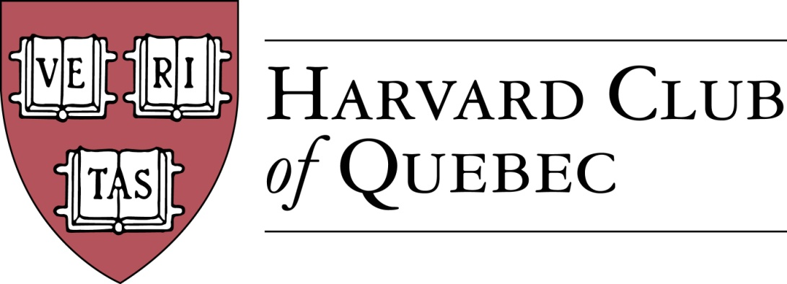

Minutes of the Harvard Club of Québec
Board of Directors Meeting
Held on 11 January 2017 in Montréal

PRESENT: Marc Novakoff (President), Han-ru Zhou (Executive Vice-President), Anna Piotrowska (Secretary), Marco Cianflone (Treasurer), Joseph Cianflone (Director PR via telephone), Alexandre Abecassis (director at large), André Picard (director at large), Cassy Wang (VP Communications)
OBSERVERS : Solange Blanchard, Matt Desruisseau
ABSENT: Marie-Pier St-Hilaire, Erinn Wattie, Louis Philippe Maurice, Morgan Carter.

AGENDA:

- QUORUM (AKP)—Anna Piotrowska confirms quorum.

- MINUTES PAST MEETINGS (AKP)—Minutes are approved.

- REVIEW OF PAST ACTIVITIES—No events since the last board meeting.

- FINANCE/TREASURY
  - Treasury Review (MC)— $2,962.00 current balance.
  - Club Status Committee Update (HRZ)—Thanks to the set up of the internet account on the registre des entreprises, annual renewals will be done online from now on.

- BUILDING UP THE CLUB
  - Active members: 236 => 241(AKP)
  - Friends of Club list: Han Ru is the custodian of this list from now on and will clean up this list.
  - Facebook Page Members: 137 => 140 (CW)

- Communication (CW/JC/AKP/HRZ)
  - Digital Strategy (JC)
    - Website—Anna and Han Ru met and updated the website.
    - The procedure for publicizing new events and sending newsletters is as follows: event organizers should send one page announcements to Marc who will approve them and transmit them to Joe, Anna, and Han Ru. A common format for website event announcements and newsletter will be developed, together with instructions on how to post them. Eventbrite, if applicable, should be handled by event organizers.
  - Newsletter (CW)
    - 3rd Edition input—no response from Cassey

- Sponsorship + Advertising (Solange)
    - Events Portable Banner (JC & MC)—under design. Solange will have the design ready in 10 days.
    - Template letter & “Package” (JC/SB)—Solange still needs information for the sponsorship package. The steps in developing the package are as follow: 1) image and message; 2) decide on the design; 3) produce a generic sponsorship letter 4) customization for specific events (e.g. Morgan’s event). Drafts will be distributed to the directors; in early February; final presentation will take place at the next Board Meeting on March 21.

- External Relations + Multi-Club Efforts (JC)--Lunch will be organized with the Oxford Club soon.

- Community Service (MMC/AKP)
    - Le Chainon (to be organized in mid- to late February)

- 2017 FORTHCOMING EVENTS
  - 11 January – GNN (MC)—next time to be organized at a different location
  - 23 February - Social Entrepreneurship Event (MMC/LP)—to be moved by one month
    - Sid Lee Location, 4-6 persons panel, multi-club event, HAA Speaker Bureau
  - 4 or 5 April – Guy St-Jacques, Former Canadian Ambassador to China
    - Lunch presentation on China and Geopolitics
  - Speaker Series For Young Professionals (SSFYP) (Mitch Joel event)—wait until the next board meeting and if not confirmed, it will be taken off the agenda.
  - Museum of Fine Arts Event with Hilliard Goldfarb (JC + Arts Committee)—targeting late April
  - History of the Russian Consulate in Montreal Event (MN) => Spring
  - MAC (Musee d’Art Contemporain), Alexandre Taillefer (AP) => Spring
  - New City Vanguard Conference (MC)
  - Annual Quebec City Club Dinner (MPS/BP?) => Date?
    - La Citadelle de Québec - Le Cercle de la Garnison
    - Invitation to US Consul
  - Marc proposes informal luncheons on topics of interest for 12 people
  - Cabane a sucre event (March)

- Harvard Prize Book Program (MN)—this is the time to contact schools for this year’s graduation. Principals should be contacted. Picture of the award recipient should be featured in the newsletter.
  - College Jean-De-Brebeuf - HRZ
  - Marianopolis College – MM/AP
  - Royal West High School – MMC
  - St-Thomas - MC
  - College Stanislas – MN
  - Others

- Next Board Meetings & AGM date
  - March 21, 2017 in Marco’s office.

- Others/Varia
  - 2017
    - Montreal - 375 Anniversary
    - Canada – 150 Anniversary
    - Expo 67 – 100 Anniversary
  - Scholarship to honour Governor General David Johnson Lu Auerbach
  - HAA Leadership Conference
    - 9-10 February, 2017

18.06 Meeting adjourned.

Minutes prepared by Anna Piotrowska.

Marc Novakoff  President | Anna Piotrowska  Secretary

