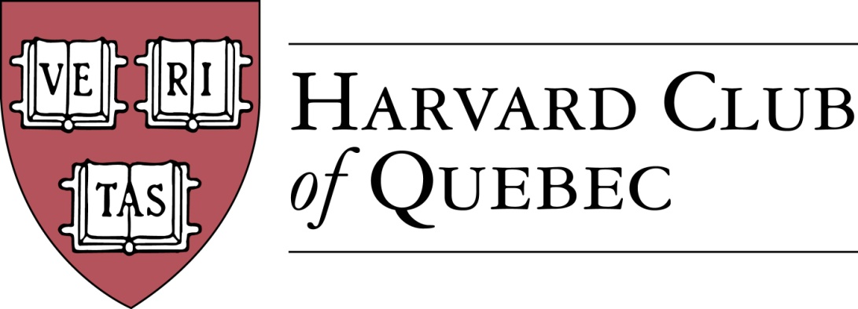 Montreal, September 20, 2017

Minutes of the Harvard Club of Québec
Board of Directors Meeting
Held on 20 September 2017 in Montréal

PRESENT: Marc Novakoff (President), Han-ru Zhou (Executive Vice-President), Anna Piotrowska (Secretary), Marco Cianflone (VP Communications), Solange Blanchard, Matt Desruisseau, André Picard, Derek McKee
ABSENT: Joseph Cianflone (VP, External Relations), Alexandre Abecassis (Treasurer), Morgan Carter

AGENDA:

- QUORUM (AKP) – Quorum confirmed

- ADOPTION OF THE AGENDA (AKP) – Agenda adopted

- MINUTES PAST MEETINGS (AKP) – Minutes approved

- REVIEW OF PAST ACTIVITIES
  - 7 June - US Consul Event (JC)
  - 8 June – MBAM Chagall Event (MD) – MD will make retrieve and post the picture from the event
  - 12 June – AGM & GNN (MC) – new venue to be found, a long term solution, potentially the University Club
  - 15 September – HCQ Annual Dinner in Qc City (BP/HRZ) – the event drew 14 participants and was a success

- FINANCE/TREASURY
  - Treasury Review (AA) – going forward, Alexandre Abecassis is to submit a detailed quarterly statement based on the template provided by Marco Cianflone.
  - Club Status Committee Update (HRZ)

- BUILDING UP THE CLUB
  - Active members: 241 => 286 (AKP)
  - Friends of Club list: 128 => 125 (AKP) – only the official excel spreadsheet on gmail drive is to be used for dissemination to Friends for consistency’s sake. All other Friends mailing lists are to be removed from the gmail account.
  - Facebook Page Members: 140 => 169 (MC)

- SOCIAL AND CULTURAL EVENTS PLANNED FOR 2017 – going forward, two categories will be established: forthcoming events with specific dates in the upcoming year and potential events which might require longer planning.

  - Forthcoming events
Month | Date and event | Organizer
October 2017 | Oct. 15: Apple picking  Oct. 19 : Welcome to Your City | AKP  Marco C.
November 2017 | Nov. 6 : M. Côté, PDG Investissement Québec, Telus Hosted  Nov. 18 : Harvard-Yale Game | SB  Marco C.
December 2017 | TBC: MAC with Alexandre Taillefer | AP
January 2018 | Jan. 9: GNN | Marco C.
February 2018 | TBC: Meeting with the Italian Consul | JC/Marco
March 2018 | TBD: History of the Russian Consulate in Montréal  TBC: Talk with the Mexican Ambassador to Canada | MN  MN/HRZ
April 2018 | TBC: Cabane a sucre  TBC: Grand Ballets | Marco /AKP  MD
May 2018 | TBD: Cleaning of Mt Royal (Community Service) | AKP
June 2018 | TBD: Reception at American Consul’s Residence  TBC: GNN and AGM | JC  Marco C

  - Potential Events
    - Social Entrepreneurship Event (MMC/LP)--Sid Lee Location, 4-6 persons panel, multi-club event, HAA Speaker Bureau
    - Speaker Series For Young Professionals (SSFYP)--Mitch Joel from Twist Image (AP), Author of Six Pixels of Separation and Ctrl, Alt, Del.
    - Museum of Fine Arts Event with Hilliard Goldfarb (JC + Arts Committee)
    - SAP sponsored events (SB)
    - Associate Justice Stephen Breyer (SCOTUS) (HRZ)
    - Garden Party with Oxbridge and other multi-club initiatives (JC)

- Community Service
  - See cleaning of Mt Royal event above

- Communication/Advertising/Sponsorships
  - Digital Strategy (MC)
    - Website – MN suggests to include past Harvard Book Prize recipients on the website; AP suggests to include past testimonials about events from participants and speakers
    - Social media – given that the Facebook page is accessible to members only, a Twitter account will be used to publicized recent events.
    - Newsletter (MC)
    - Communication and Event Templates – MC discusses the procedure for advertising events
  - Advertising (JC)
  - Sponsorship (SB)
    - Template letter & “Package” (SB) -- Finalized package to be placed on the shared drive
    - Events Portable Banner (JC & MC) – the use of Harvard visuals to be confirmed

- Harvard Prize Book Program (MN)
  - Marianopolis College – MM/AP – Anna to confirm with Mitchell Miller if he wants to continue, otherwise AP will take over
  - Royal West High School – MMC
  - St-Thomas - MC
  - College Stanislas – MN / AKP
  - Marie de France - MN
  - Collège de Montréal – Martine Valois, LL.M. ’91
  - Other – HRZ

- Nominating committee: MN, AKP, HRZ – no new potential directors or officers identified

- New Potential Committees
  - Young Alumni Committee (JC)
  - Prospective Students Committee/Officer
    - Claude Roy – it is suggested that Claude Roy be connected with Paul Lasko regarding the college interviews

- Next Board Meetings & AGM date
  - January 9 (vs January 23), 2018
  - GNN New Location (MC)

