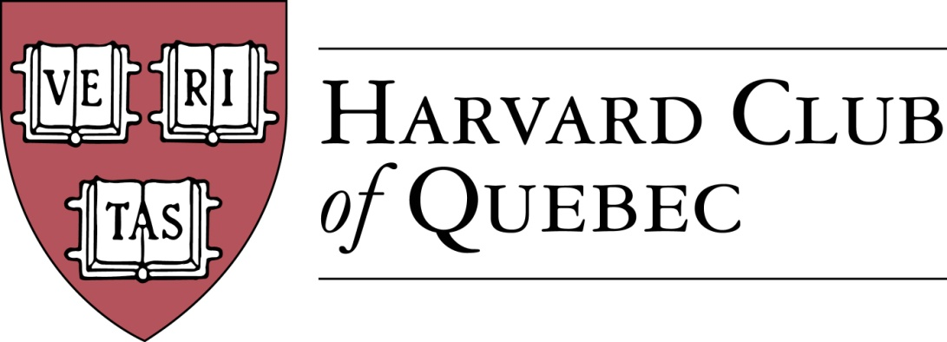

Minutes of the Harvard Club of Québec
Board of Directors Meeting
Held on March 22, 2018, 17:00-18:30, in Thomson House, McGill, Montréal

PRESENT: Marc Novakoff (President), Han-ru Zhou (Executive Vice-President), Anna Piotrowska (Secretary), Marco Cianflone (VP Communications), Joseph Cianflone (VP External Relations), Matt Desruisseau, Alexandre Abecassis (Treasurer), Solange Blanchard, Derek McKee
ABSENT:, Morgan Carter, André Picard

- QUORUM (AKP) --confirmed

- ADOPTION OF THE AGENDA (AKP) -- adopted

- MINUTES PAST MEETINGS (AKP) --adopted

- REVIEW OF PAST ACTIVITIES
  - HAA Leadership conference in February—Han-ru Zhou attended on behalf of HCQ
  - Global Networking Night (MC), January 9—some 30 members attended this event. However, the HAA decided to discontinue the global networking night.

ACTION ITEM: at the next AGM, we will propose a motion to question this decision and contact HAA for further clarifications.

- FINANCE/TREASURY (AA)—the account is still locked and for this reason the statement could not be produced.

ACTION ITEM :
- (AA) Reset the online access for AA (asap)
- (AA) Reconcile the account and produce an updated dtailed statement by the June 18 AGM
- (MC) Job description for the treasurer : Marco will draft it and Alexandre will review it.

- BUILDING UP THE CLUB
  - Active members: 286 => 286
  - Friends of Club: 125 => 127
  - Facebook Page Members: 169 => 176. The directors discussed the recent activity on the HCQ FB account by one of the members.

ACTION ITEM :
- (HRZ) Han-ru will draft a policy on Facebook posts and circulate it among the directors before the June 18 meeting. These guidelines will be posted on FB. If HCQ members don’t comply with the guidelines, further action will be taken, including blocking the members.

- FORTHCOMING EVENTS
  - Mexican Ambassador to Canada Dionisio Pérez-Jacome & HKS Prof. Robert Lawrence on NAFTA (HRZ) => April 6, 2018 – thus far, 79 paid registrations
  - Cabane à sucre (HRZ) => April 22 2018
  - 10 Theses on Canada in the world in the 21st Century with Dr. Irvin Studin (Diego Osorio) => May 2, 2018. ACTION ITEM : the following venues will be proposed to Diego : Atwater Club and Fasken Martineau.
- COMMUNITY SERVICE: La grande corvee du Mont Royal (Saturday, May 5th)
- History of the Russian Consulate in Montreal Event (MN) => spring 2018
- Grands Ballets (MD) => spring 2018. ACTION ITEM: Matt will ask for two potential dates in May or June
- M. Côté, PDG Investissement Québec (SB) => spring 2018. ACTION ITEM : Andre Picard as supposed to follow up on this one.
- Club Annual Dinner in Quebec City (BP/HRZ) => summer/fall 2018
- Marc-André Blanchard, Canadian Ambassador to the United Nations (HRZ) => fall 2018/winter 2019
- Montreal Canadiens event (TBC)

- POTENTIAL EVENTS
  - Annual Cocktail Reception at the US Consul Residence (JC) => TBC
  - Calder exhibit at the Museum of Fine Arts Event with Hilliard Goldfarb (MD/AP)
  - MAC (Musee d’Art Contemporain) & Alexandre Taillefer (AP/MD)
  - Italian Consul (MC)
  - SAP sponsored events (SB)—the marketing package has been forwarded to Anna who will follow up on this.
  - Garden Party with Oxbridge (JC)
  - Julie Payette event organized jointly with the Harvard Club of Ottawa

- COMMUNICATIONS/ADVERTISING (MC)
  - Digital Strategy (MC)
    - Website
    - Social media
  - Newsletter (MC) – discussion about the need for newsletter and how it could be reconceptualised.
    - 3rd Edition input
    - Advertising
  - Communication and Event Templates
ACTION ITEM : Communications will be moved to the start of each BoD meeting in order to allow for a more in-depth discussion.

- SPONSORSHIPS (SB)
  - Template letter & “Package” (SB) –already produced, so no need to include this item in future agendas
  - Events Portable Banner (JC/MC)—ACTION ITEM : SB will make sure the banner is ready in April
  - 2018-19 Preliminary Calendar of Club Events (HRZ/AKP/SB)—done and posted on the shared drive.

- EXTERNAL RELATIONS (JC)
  - Events advertising/publicity & media coverage
  - Multi-Club initiatives

- HARVARD PRIZE BOOK PROGRAM
  - Marianopolis College – MM/AP –ACTION ITEM: Anna will follow up with Mitch about this prize.
  - Royal West High School – MMC—ACTION ITEM: follow up needed with Morgan
  - St-Thomas – MC
  - College Stanislas – MN/AKP
  - Marie-de-France – MN
  - Collège Ste-Anne – Martine Valois, LL.M. ’91/HRZ

- NOMINATING COMMITTEE (MN/HRZ/AKP)
  - New potential Officers
  - New potential Directors

- NEW POTENTIAL COMMITTEES
  - Young Alumni Committee (JC)
  - Prospective Students Committee with Claude Roy as potential Officer (MN)
ACTION ITEM : MN will follow up with the two HCQ members who were interested in spearheading these committees.

- NEXT BOARD MEETING & AGM (MN/HRZ)
  - AGM/GNN/New board meeting (MN/HRZ/MC): June 18, 2018-03-26
ACTION ITEM : Marco (MC) will propose a venue.

There being no further business, the meeting concluded at 6.30 pm.

* * *

Minutes prepared by Anna K. Piotrowska.

Marc Novakoff  President | Anna K. Piotrowska  Secretary

